**Structure Of HTML**

**HTML: HyperText Markup Language**

**HTML** (HyperText Markup Language) is the most basic building block of the Web. It defines the meaning and structure of web content. Other technologies besides HTML are generally used to describe a web page's appearance/presentation ([CSS](https://developer.mozilla.org/en-US/docs/Web/CSS)) or functionality/behavior ([JavaScript](https://developer.mozilla.org/en-US/docs/Web/JavaScript)).

"Hypertext" refers to links that connect web pages to one another, either within a single website or between websites. Links are a fundamental aspect of the Web. By uploading content to the Internet and linking it to pages created by other people, you become an active participant in the World Wide Web.

HTML uses "markup" to annotate text, images, and other content for display in a Web browser. HTML markup includes special "elements" such as [<head>](https://developer.mozilla.org/en-US/docs/Web/HTML/Element/head), [<title>](https://developer.mozilla.org/en-US/docs/Web/HTML/Element/title), [<body>](https://developer.mozilla.org/en-US/docs/Web/HTML/Element/body), [<header>](https://developer.mozilla.org/en-US/docs/Web/HTML/Element/header), [<footer>](https://developer.mozilla.org/en-US/docs/Web/HTML/Element/footer), [<article>](https://developer.mozilla.org/en-US/docs/Web/HTML/Element/article), [<section>](https://developer.mozilla.org/en-US/docs/Web/HTML/Element/section), [<p>](https://developer.mozilla.org/en-US/docs/Web/HTML/Element/p), [<div>](https://developer.mozilla.org/en-US/docs/Web/HTML/Element/div), [<span>](https://developer.mozilla.org/en-US/docs/Web/HTML/Element/span), [<img>](https://developer.mozilla.org/en-US/docs/Web/HTML/Element/img), [<aside>](https://developer.mozilla.org/en-US/docs/Web/HTML/Element/aside), [<audio>](https://developer.mozilla.org/en-US/docs/Web/HTML/Element/audio), [<canvas>](https://developer.mozilla.org/en-US/docs/Web/HTML/Element/canvas), [<datalist>](https://developer.mozilla.org/en-US/docs/Web/HTML/Element/datalist), [<details>](https://developer.mozilla.org/en-US/docs/Web/HTML/Element/details), [<embed>](https://developer.mozilla.org/en-US/docs/Web/HTML/Element/embed), [<nav>](https://developer.mozilla.org/en-US/docs/Web/HTML/Element/nav), [<search>](https://developer.mozilla.org/en-US/docs/Web/HTML/Element/search), [<output>](https://developer.mozilla.org/en-US/docs/Web/HTML/Element/output), [<progress>](https://developer.mozilla.org/en-US/docs/Web/HTML/Element/progress), [<video>](https://developer.mozilla.org/en-US/docs/Web/HTML/Element/video), [<ul>](https://developer.mozilla.org/en-US/docs/Web/HTML/Element/ul), [<ol>](https://developer.mozilla.org/en-US/docs/Web/HTML/Element/ol), [<li>](https://developer.mozilla.org/en-US/docs/Web/HTML/Element/li) and many others.

An HTML element is set off from other text in a document by "tags", which consist of the element name surrounded by < and >. The name of an element inside a tag is case-insensitive. That is, it can be written in uppercase, lowercase, or a mixture. For example, the <title> tag can be written as <Title>, <TITLE>, or in any other way. However, the convention and recommended practice is to write tags in lowercase.

[Introduction to HTML](https://developer.mozilla.org/en-US/docs/Learn/HTML/Introduction_to_HTML)

This module sets the stage, getting you used to important concepts and syntax such as looking at applying HTML to text, how to create hyperlinks, and how to use HTML to structure a web page.

[Multimedia and embedding](https://developer.mozilla.org/en-US/docs/Learn/HTML/Multimedia_and_embedding)

This module explores how to use HTML to include multimedia in your web pages, including the different ways that images can be included, and how to embed video, audio, and even entire other webpages.

[HTML tables](https://developer.mozilla.org/en-US/docs/Learn/HTML/Tables)

Representing tabular data on a webpage in an understandable, accessible way can be a challenge. This module covers basic table markup, along with more complex features such as implementing captions and summaries.

[HTML forms](https://developer.mozilla.org/en-US/docs/Learn/Forms)

Forms are a very important part of the Web — these provide much of the functionality you need for interacting with websites, e.g. registering and logging in, sending feedback, buying products, and more. This module gets you started with creating the client-side/front-end parts of forms.

[Use HTML to solve common problems](https://developer.mozilla.org/en-US/docs/Learn/HTML/Howto)

Provides links to sections of content explaining how to use HTML to solve very common problems when creating a web page: dealing with titles, adding images or videos, emphasizing content, creating a basic form, etc.

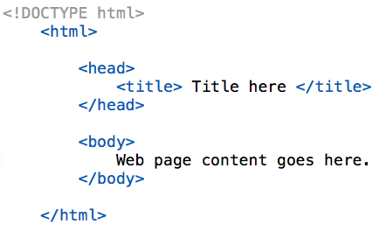

**HTML Tags**

**<DOCTYPE>**

We use the DOCTYPE tag while starting the HTML file. It specifies the document type and version of HTML being used.

https://miro.medium.com/v2/resize:fit:151/1*YlOd5-sV-BkZF59n2edYhw.jpeg

**<html>**

Defines the root element of an HTML page. lang attribute is used for the language that tells the browser the language is en (English).

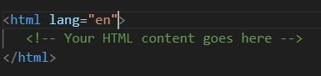

**<head>, <title> and <link>**

The head contains meta-information about the document, such as title, links to the stylesheets, and scripts.

The title tag include inside the head tag. The title tag sets the title of the HTML document, displayed in the browser’s title bar.

The link tag is include inside the head tag. The link tag is used to connect the other files such as CSS files with HTML.

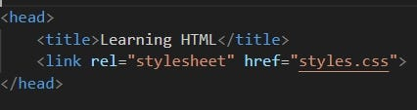

**<h1> to <h6>**

Defines headings of different levels. h1 is commonly used as the main heading and h2 is used as a subheading and so on. It depends on the requirements that which h tag we can use according to the scenario.

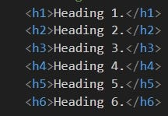

**<p>**

Represents a paragraph of text. We can use as many paragraph as we want. The default color for text is white but we can change styling with CSS.

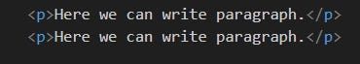

**B0ld Tag ;-**

The tag in HTML is used to make text bold without indicating any extra importance or emphasis. Unlike the **tag.**

**Italic Tag *;-***

**The tag in HTML is used to display the content in italic style.**

`

THANK **YOU**